**THAVISHALA CHARPITHA SRE**

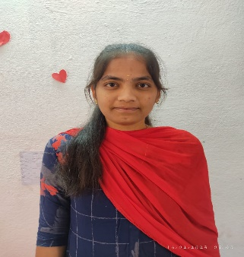Contact No**: +919014500279**

Email ID**: charpithasreethavishala@gmail.com**

9-117,

Chinthala peta village,

Dhone mandal-518222,

kurnool District, Andhra Pradesh**.**

# CAREER OBJECTIVE

|  |  |  |  |  |
| --- | --- | --- | --- | --- |
| |  |  | | --- | --- | | To enhance my knowledge**,** skills and experience by getting involved in a challenging work environment and utilise | | | them for personal and organisation growth to the best of my ability. |  | |

**ACADEMIC QUALIFICATION**

|  |  |  |  |  |  |  |  |
| --- | --- | --- | --- | --- | --- | --- | --- |
| **QUALIFICATION** | |  | | --- | | **INSTITUTE NAME** | | |  | | --- | | **YEAR OF** | | **PASSING** | | |  | | --- | | **PERCENTAGE** | |
| |  |  |  |  | | --- | --- | --- | --- | | Bachelor of Technology | | | | | in Computer Science | | |  | | and Engineering | |  | | (pursuing) |  | | Annamacharya Institute of Technology and Sciences,Rajampet | |  | | --- | | 2024 | | 9.99.99   |  | | --- | | 9.01  (till now) | |  | | |
| Intermediate | Sri Chaitanya  Junior College,  Pasupala road,  Kurnool-518002 | 2020 | 9.73   |  | | --- | | (including 2 years) | |
| |  | | --- | | S.S.C | | Sri Sudha English Medium High School,Dhone-518222 | 2018 | |  | | --- | | 9.8 | |

# TECHNICAL QUALIFICATIONS

**. C**

**.** HTML

. Python

. CSS

. SQL

. JAVA

# CERTIFICATES

Certification on participating “Innovation & Entrepreneurship” Organised by innovation & incubation center of AITS

Certification on participating in internship on “Data Analytics” Organised by SmartBridge

Certification on participaying in hackathon on”waste segregation and disposal “through iot technology

## SKILLS

. Hard Working

. Forthright

. Quick Learner

. Leadership

**PERSONAL DETAILS**

Name : Thavishala Charpitha Sree

Date of Birth : 06-03-2003

Gender : Female

Father’s Name : Mr. Thavishala Vikramarka Reddy

|  |  |  |
| --- | --- | --- |
| Mother’s name | : Mrs.Thavishala Lalithamma |  |
| Languages known | : English,Telugu |  |

Marital Status : Unmarried

Permanent Address : 9-117,Chinthala Peta Village,

DhoneMandal-518222,

Kurnool District,Andhra Pradesh,India

Hobbies : Listening Music, Art and Craft

## DECLARATION

I solemnly declare that all the above information is correct to the best of my knowledge and belief.

**Date:**03-07-2023

**Place:** Dhone

# (THAVISHALA CHARPITHA SREE )